Add Linked Web pages to your Node.js Website

1 Go to DevOps Services at https://hub.jazz.net/ and SIGN IN.
2 Start a new project named codenode2
3 Open the views folder, then Click on indexwithlinks.ejs and copy lines 9-15.

4 Click on index.ejs and paste the content after line 8. Index.ejs should now look like indexwithlinks.ejs.
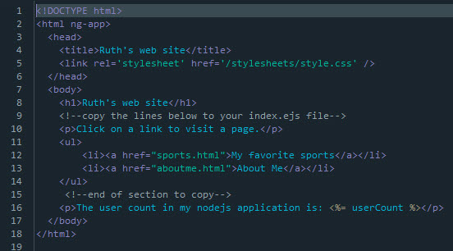
5 Use Live Edit Quick Restart to update your application.
6 Follow the URL link to your application. In your application, test the links to My favorite sports and About Me pages
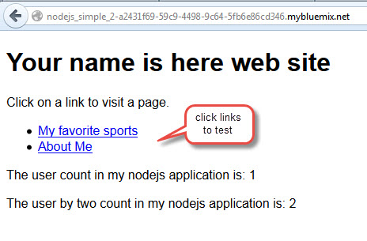

7 Back in DevOps Services, Click on public directory.
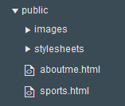
8 Edit the text in aboutme.html.
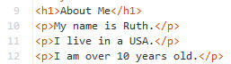

9 Edit the img line in aboutme.html to reference a picture which you will upload in the next steps.

10 In the public folder, Click on images.
11 Select File, Import, File or zip archive.
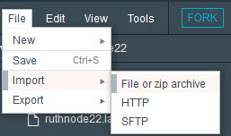
12 Navigate and select your image to upload.
13 Edit sports.html. Insert links to your favorite sports and games.
14 Use the Live Edit Quick Restart to update your website. Check that your image displays and your new links work.
15 Experiment with any HTML features that you want.

